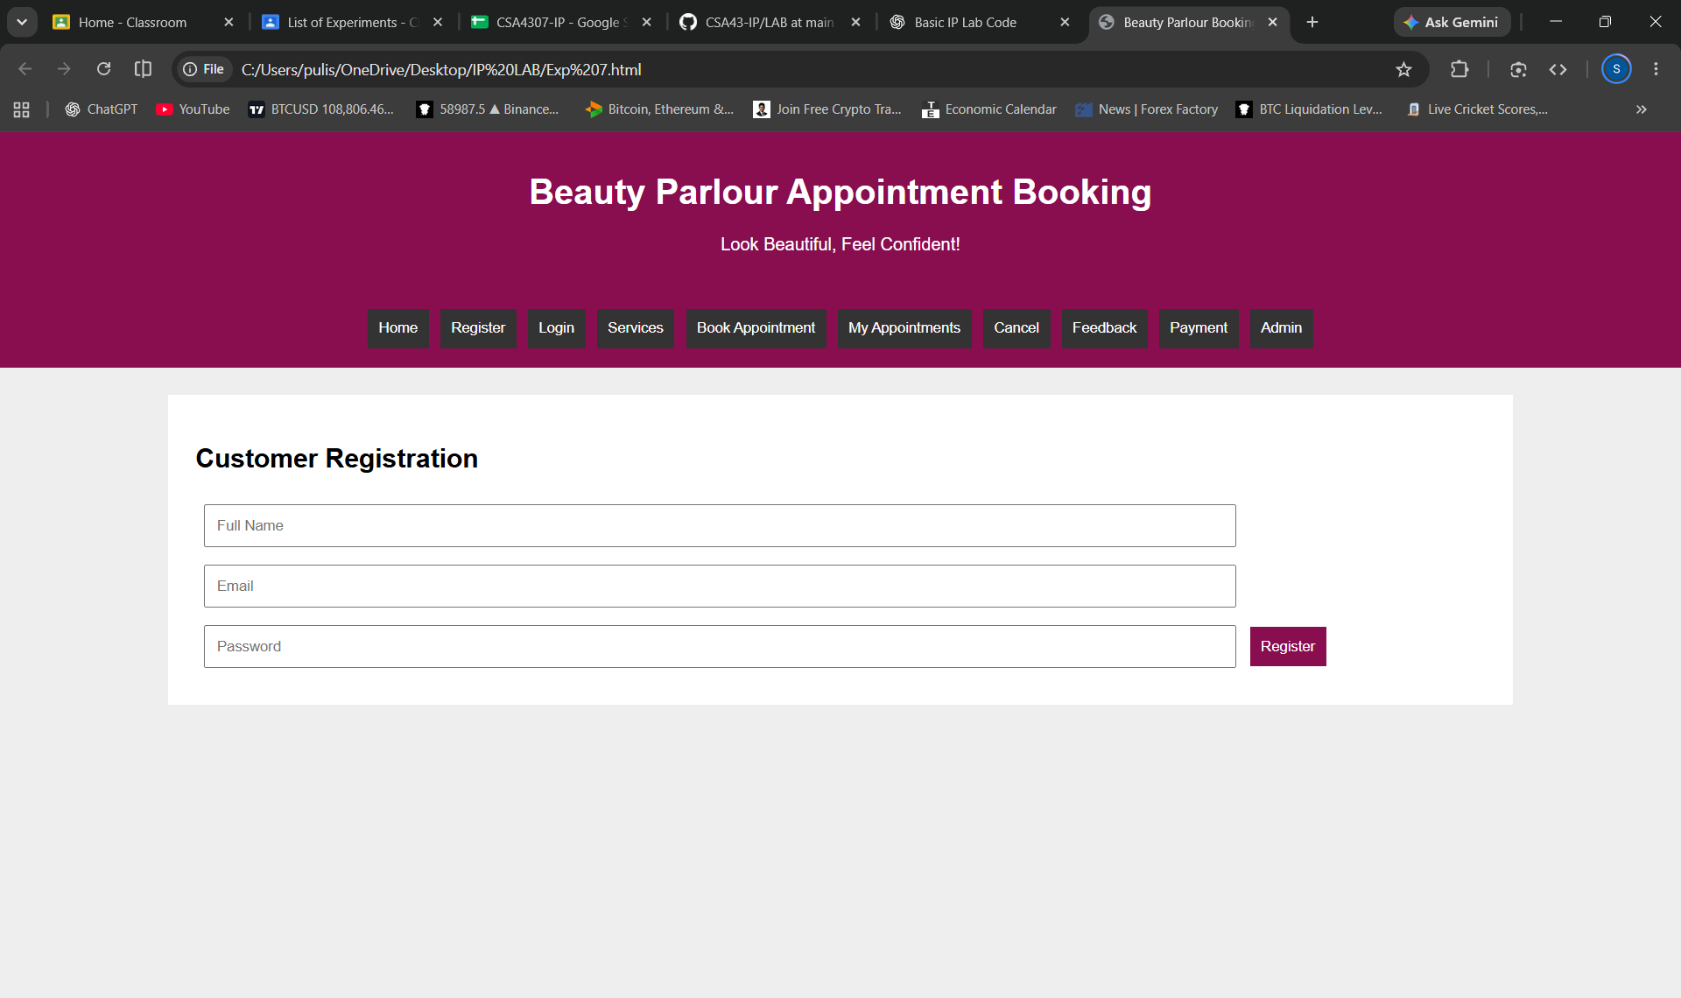
<!DOCTYPE html>
<html>
<head>
<title>Beauty Parlour Booking</title>
<style>
body{font-family:Arial;margin:0;background:#eee}
header,nav{background:#880e4f;color:white;text-align:center;padding:15px}
nav button{background:#333;color:white;border:0;padding:10px;margin:3px;cursor:pointer}
.box{background:white;margin:25px auto;padding:25px;width:80%;box-sizing:border-box}
input,select,textarea{padding:10px;margin:8px;width:80%;box-sizing:border-box}
button{padding:10px;background:#880e4f;color:white;border:0;cursor:pointer}
.page{display:none}
#home{display:block}
</style>
</head>
<body>

<header>
<h1>Beauty Parlour Appointment Booking</h1>
<p>Look Beautiful, Feel Confident!</p>
</header>

<nav>
<button onclick="show('home')">Home</button>
<button onclick="show('register')">Register</button>
<button onclick="show('login')">Login</button>
<button onclick="show('services')">Services</button>
<button onclick="show('booking')">Book Appointment</button>
<button onclick="show('mybookings')">My Appointments</button>
<button onclick="show('cancel')">Cancel</button>
<button onclick="show('feedback')">Feedback</button>
<button onclick="show('payment')">Payment</button>
<button onclick="show('admin')">Admin</button>
</nav>

<div class="box page" id="home">
<h2>Welcome to Beauty Parlour</h2>
<p>Book your favourite beauty services easily online.</p>
</div>

<div class="box page" id="register">
<h2>Customer Registration</h2>
<input placeholder="Full Name">
<input type="email" placeholder="Email">
<input type="password" placeholder="Password">
<button onclick="alert('Registration successful')">Register</button>
</div>

<div class="box page" id="login">
<h2>Customer Login</h2>
<input placeholder="Username">
<input type="password" placeholder="Password">
<button onclick="alert('Login successful')">Login</button>
</div>

<div class="box page" id="services">
<h2>Available Services</h2>
<p>Haircut - ₹200</p>
<p>Facial - ₹500</p>
<p>Hair Spa - ₹700</p>
<p>Bridal Makeup - ₹3000</p>
</div>

<div class="box page" id="booking">
<h2>Book Appointment</h2>
<input id="customer" placeholder="Customer Name"><br>
<select id="service">
<option>Haircut</option>
<option>Facial</option>
<option>Hair Spa</option>
<option>Bridal Makeup</option>
</select><br>
<select id="stylist">
<option>Stylist A</option>
<option>Stylist B</option>
<option>Stylist C</option>
</select><br>
<input type="date" id="date"><br>
<input type="time" id="time"><br>
<button onclick="bookAppointment()">Book Appointment</button>
<p id="bookingResult"></p>
</div>

<div class="box page" id="mybookings">
<h2>My Appointments</h2>
<p id="myBookingResult">No appointments booked.</p>
</div>

<div class="box page" id="cancel">
<h2>Cancel Appointment</h2>
<button onclick="cancelAppointment()">Cancel My Appointment</button>
<p id="cancelResult"></p>
</div>

<div class="box page" id="payment">
<h2>Appointment Payment</h2>
<select id="paymentType">
<option>Full Payment</option>
<option>Partial Deposit</option>
</select><br>
<button onclick="pay()">Pay Now</button>
<p id="paymentResult"></p>
</div>

<div class="box page" id="feedback">
<h2>Customer Feedback</h2>
<input id="feedbackName" placeholder="Your Name"><br>
<textarea id="feedbackText" placeholder="Write your feedback"></textarea><br>
<button onclick="submitFeedback()">Submit Feedback</button>
<p id="feedbackResult"></p>
</div>

<div class="box page" id="admin">
<h2>Admin Panel</h2>
<input id="serviceName" placeholder="Service Name">
<input id="servicePrice" type="number" placeholder="Service Price">
<button onclick="addService()">Add Service</button>
<h3>Appointment Report</h3>
<p id="adminResult">No new services added.</p>
</div>

<script>
let appointment="";

function show(id){
document.querySelectorAll('.page').forEach(p=>p.style.display='none');
document.getElementById(id).style.display='block';
}

function bookAppointment(){
let n=document.getElementById('customer').value;
let s=document.getElementById('service').value;
let st=document.getElementById('stylist').value;
let d=document.getElementById('date').value;
let t=document.getElementById('time').value;

if(!n||!d||!t){
alert('Enter all appointment details');
return;
}

appointment='Customer: '+n+' | Service: '+s+
' | Stylist: '+st+' | Date: '+d+' | Time: '+t;

document.getElementById('bookingResult').innerText='Appointment booked successfully!';
document.getElementById('myBookingResult').innerText=appointment;
}

function cancelAppointment(){
appointment="";
document.getElementById('myBookingResult').innerText='No appointments booked.';
document.getElementById('cancelResult').innerText='Appointment cancelled.';
}

function pay(){
document.getElementById('paymentResult').innerText=
'Payment selected: '+document.getElementById('paymentType').value+' (Demo)';
}

function submitFeedback(){
let n=document.getElementById('feedbackName').value;
let f=document.getElementById('feedbackText').value;
document.getElementById('feedbackResult').innerText=
n&&f?'Thank you for your feedback!':'Enter your name and feedback';
}

function addService(){
let n=document.getElementById('serviceName').value;
let p=document.getElementById('servicePrice').value;
document.getElementById('adminResult').innerText=
n&&p?'Service Added: '+n+' | Price: ₹'+p:'Enter service details';
}
</script>

</body>
</html>

